## **Hands-On Activity: Your R Markdown notebook**

**TOTAL POINTS 1**

1.

Question 1



In this activity, you’ll create an R Markdown notebook to keep track of your data analysis process in R.

### Getting started with R Markdown



R Markdown is a file format for making dynamic documents with R. These documents, also called notebooks, are records of analysis that help you and your team members and stakeholders understand what you did in your analysis to reach your conclusions. You can publish a notebook as an html, pdf, or Word file, or in another format like a slideshow.

At any point during this activity, you can consult the [R Markdown Cheat Sheet](https://rstudio.com/wp-content/uploads/2015/02/rmarkdown-cheatsheet.pdf).

You can use this resource as a reference guide for all things R Markdown, from opening a file to publishing a final report of your analysis.

### Selecting your analysis



In this course, you’ve had the chance to practice and save files of your analysis in RStudio. To get started, open up an analysis that you have saved.

You can use Open File in the File menu:

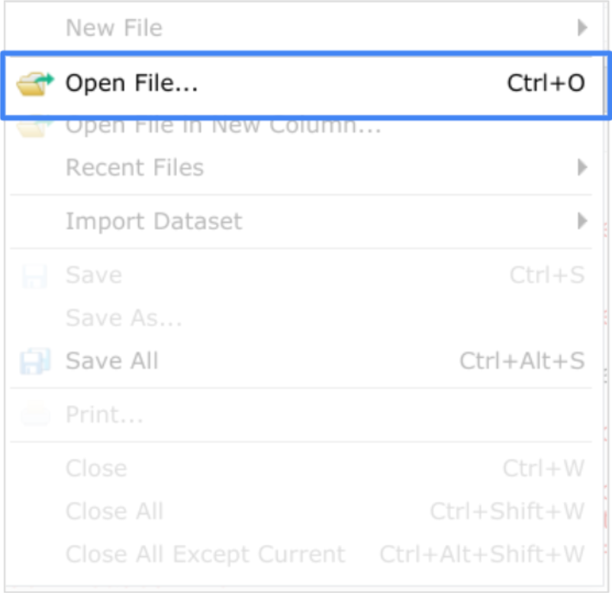

Or you can use the Files tab in the bottom-right viewer pane:

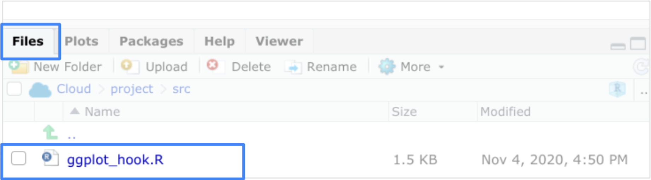

### Reviewing your programming



Now, go ahead and review your analysis. When you create an R Markdown notebook, you want to be able to share it with others, so they can understand your process and conclusions. You may also want to keep it for your own records as a way to keep track of your progress using R for analysis.

As you review, think about the data you pulled from and the functions you used to analyze it. Read through your code to get a sense of your thinking so that you can comment on it in your notebook. You’ll then have a more complete record of your overall thought process that you and others will be able to understand.

### Opening an Rmd file



Now open a new R Markdown, or Rmd, file to begin building the basic structure of your notebook: File -> New File -> R Markdown.

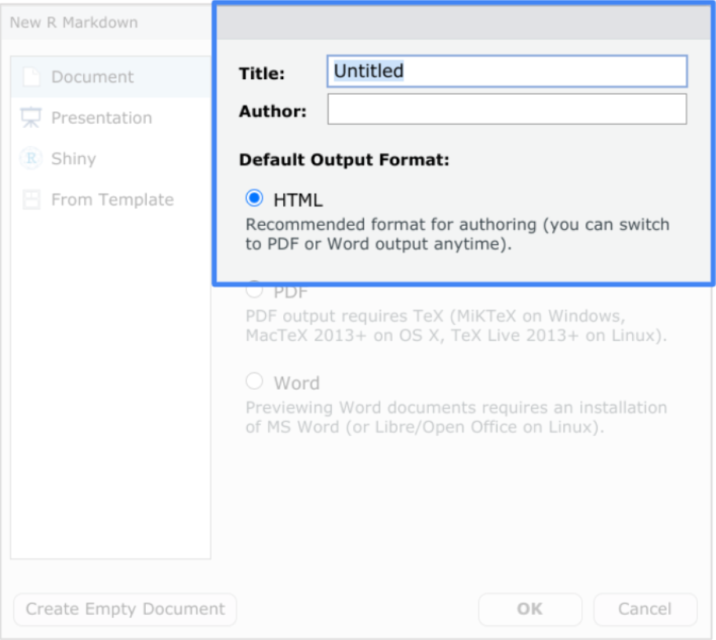

In the dialog box that opens, add a title for your notebook. Name it something that will help you easily recognize what your analysis is about (for example, Penguins Plots). Type your name in the Author field (for example, DA Cert).

For now, leave the file in the recommended HTML output format. When you render the file later, it will appear as an HTML report. You can always change it to a pdf or Word file later.

Click OK and an Rmd file appears in a new tab in the script viewer pane. You should now have two tabs: one for the Rmd file and one for your analysis. You can toggle back and forth between them when you need to by clicking on the tab you want to access.

### Formatting your notebook



This first part of your notebook is the YAML header section. RStudio automatically populates this section with the information you provided and other general information, such as the date you created the file.

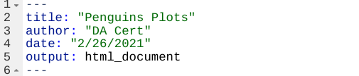

You can change the information in this section any time by adding text or by typing over the current text. Notice that each line has a number associated with it. That makes it easy to reference a location in the notebook and also for you to track where you make changes in the notebook.

The next section with the gray background is a code chunk.



Again, RStudio automatically populates the notebook with this formatted default code chunk. This chunk basically means that your code will be shown in your final report when you’re ready to render it.

All code chunks begin and end with delimiters. To start a code chunk, you can type three tick marks followed by a lowercase “r” in curly brackets:

**```{r}**

To end it, type just the three tick marks:

**```**

There are two shortcuts to adding code. On your keyboard, you can press Ctrl + Alt + I (PC) or Cmd + Option + I (Mac). Or you can click the Add Chunk command in the editor toolbar:

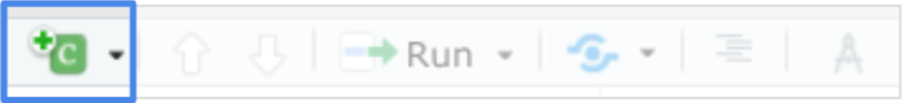

Press Enter two or three times after the default code chunk to create space between the default and the code chunk you will add. Use one of the options to add a code chunk to your file.

You can then copy the code from your analysis file and paste it in the gray area between the beginning and ending delimiters.

Next, select the rest of the content in the file and delete it. This gives you a blank space to work in to help avoid potential errors from mixing your own comments and code with the pre-existing ones in the template.

The white background is where you will type plain text with markdown syntax (e.g. line 7, 11-17). As we explained in the videos, markdown is a syntax for formatting plain text files. Using markdown makes it easier to write and format text in your notebook.

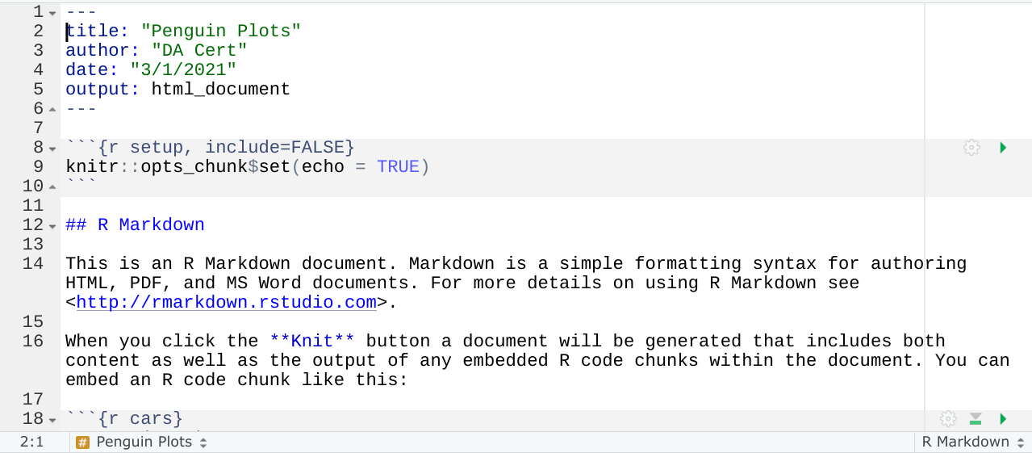

Here are some basic formatting options:

* To start a new paragraph, end a line with two spaces
* To apply italics to a word or phrase, place an asterisk at the beginning and at the end of the word or phrase, for example, *italics works*
* To apply bold to a word or phrase, place two asterisks at the beginning and at the end of the word or phrase, for example, **bold is useful**
* To create a header, type a hashtag (#) followed by a space and your text for example: # Getting Started with R Markdown

When creating headers keep the following in mind:

* Headers will appear in blue
* A single hashtag is the largest header
* The more hashtags you add (up to six), the smaller the header

To start formatting comments in your notebook, click in a line above the code chunk you added. Then type a main header for your report using a single hashtag. You might want to restate the title in the YAML in a different way or add to it with a short description.

Then add a smaller header below that to label the first part of your programming. Follow that with a description of the code chunk that you added.

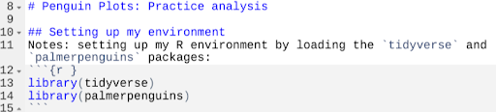

Tick marks format the text to appear as code even though the text is not in a code chunk. The tick marks in the code above create a gray background behind “tidyverse” and “palmerpenguins.”

### Continue formatting



Keep working on your formatting until you have at least three levels of headers and more descriptions for your analysis. At any point, you can click on Knit in the script pane to render the file.

When you render your file, you can check out how it will look in the format you selected when you opened the file, in this example, an HTML file.

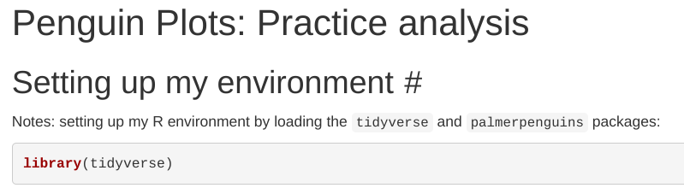

Rendering a file also automatically runs the code chunks to show the output. In this example, it shows that tidyverse was loaded using the library() function.

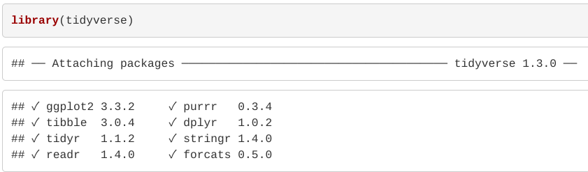

### Reflection



Take a moment to reflect on the overall process you just completed. How do you imagine yourself making use of RMarkdown notebooks in the future?

## Did you complete this activity?

**1 / 1 point**

Yes

No

**Correct**

Thank you for completing this activity! Creating an R Markdown notebook is a useful way to keep track of your programming for your own purposes. You can also use notebooks to create final reports of your analysis to share with others. It takes just a few quick steps to format a notebook in RStudio. You can also take advantage of resources like the R Markdown Cheat Sheet to make your notebooks more effective tools.